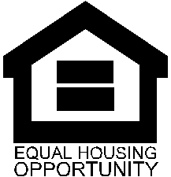
Certification of Zero Income

Re: Name: |  |  | Unit #:
 |  | Effective Date:

I certify that I currently do not have any source of income including but not limited to the following:

A job in which you are paid cash, such as babysitting, field work, temporary work or contract work (i.e. Avon, Mary Kay, Uber, Herbal Life, It Works etc.)

Cash Assistance/Gifts from parents, children, friends, or any other person or organization outside of your household to help meet your needs

By my signature, I certify that the information provided is true and correct to the best of my knowledge.

Head of Household Signature |  | Date completed:

Title 18, Section 1001 of the U.S. Code states that a person is guilty of a felony for knowingly and willingly making false or fraudulent statements to any department of the United States Government. HUD and any owner (or any employee of HUD or the owner) may be subject to penalties for unauthorized disclosures or improper uses of information collected based on the consent form. Use of the information collected based on this verification form is restricted to the purposes cited above. Any person who knowingly or willingly requests, obtains or discloses any information under false pretenses concerning an applicant or participant may be subject to a misdemeanor and fined not more than $5,000. Any applicant or participant affected by negligent disclosure of information may bring civil action for damages and seek other relief, as may be appropriate, against the officer or employee of HUD or the owner responsible for the unauthorized disclosure or improper use. Penalty provisions for misusing the social security number are contained in the Social Security Act at **208 (a) (6), (7) and (8).** Violation of these provisions are cited as violations of 42 U.S.C. Section **408 (a) (6), (7) and (8).

